Eve Tanios

12/8/23

Internet Equity Report

**Part 1**

Question 1

1. This type of sample can answer questions about the consumer broadband performance for the evaluated ISPs and specifics about internet capabilities at these sampled homes. For example, the report covers download speeds, the accuracy of advertised speeds, upload speeds, and the peak hours of usage. Though this information is important for an overall understanding, there seem to be some caveats to the data that mean that this report does not necessarily cover all demographics of the United States.
2. This type of sample cannot generalize to internet performance across the United States, as the report does not indicate any geographic metrics for choosing their samples. Additionally, there could be some questions about how the samples were chosen. There could be some bias in those that chose to be on the panel, if applicable, or perhaps cities could be overrepresented due to the volume of individual homes there.

Question 2

1. Latency, the time it takes for a data packet to travel across a network, is an important metric because it affects the perceived quality of the internet service for the customer. High latency could especially affect multiplayer games, or video calls, both of which are important to consumers. If there are differences in latency across the country, or if the latency is higher than advertised, then this could lead to large internet inequity as it directly affects the quality of service.
2. Web browsing is important to measure because it is a major aspect of the internet for consumers. If there is congestion in the network, or if the web browsing speed is not as efficient in some areas (or up to par with the advertised speed) then this could indicate internet inequity. However, it is important to note that the data from this report did not measure the speed of web browsing when there are multiple people browsing in the same household, which could be an important factor in speed and should be included in future reports if possible.

Question 3

1. The FCC’s measurement technique overcomes this potential limitation by measuring only what the ISP can control within their services. So, their measurements would be for the delivery of the ISP’s service to the entire home, and tries not to focus on individual usage such as applications that may or may not have a perceived performance based on other factors.

**Part 2**  
I analyzed the curr_ping CSV file for July 2023.

**Part 3**

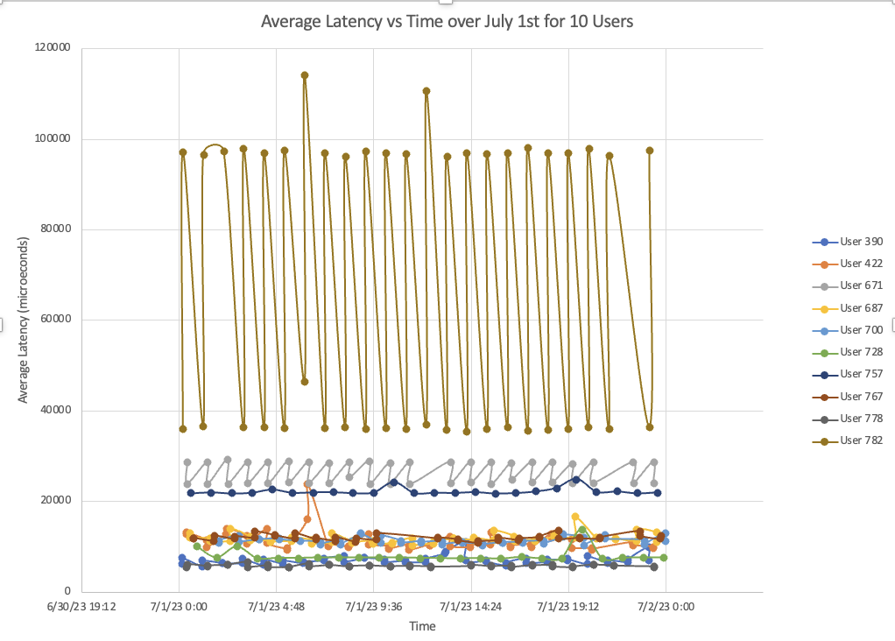

I decided to analyze the average latency over a daily period for 10 users because the latency is a determining factor for the perceived performance of the ISP service in the household. Though there is no geographic data to consider, it is clear from the graph that user 782 had the highest latency, and it was very variable, followed by user 671 and user 757. This shows that there is a clear difference in ISP service between these households. Data such as latency across households over time could be relevant to policy because the marked difference between users shows that there is a digital divide, though we are unsure as to why because of lack of data. If I was a policymaker, I would consider ways to ensure that these latency issues are not so prominent (and variable) for users like 782, and investigate why these issues might be so stark in comparison to others. Additionally, the large increase in latency found for user 422 could be of interest for the ISP or others analyzing performance over time to ensure that it remains steady across the day.

**Part 4**

1. The FCC’s dataset is inadequate for measuring digital inequity for a few major reasons, but most significantly it simply does not accurately represent the geographic and socioeconomic groups of the United States. In “Benchmarks or Equity?” by Sharma et al., the authors note that the FCC’s data, at the time of writing, did not even include a single household from Chicago, and this clear oversight shows that they most certainly also do not accurately represent across socioeconomic lines. Additionally, the FCC dataset is mostly concerned with companies meeting their advertised benchmarks and the overall download and web browsing speed, and not particularly any full comparisons across geographic or social demographics.
2. Measuring digital inequity would be much more difficult than the FCC’s current report because much more data is needed, with more controls, in order to accurately measure and compare differences. For example, geographic data would be very important considering the lifestyle and potential socioeconomic differences of households in urban areas versus rural areas. However, like in the “Benchmarks or Equity?” paper, a more granular approach could provide major insights into digital divides across different city communities and their effects for marginalized groups. Many cities, and especially Chicago, are known for having a history of racial divides within areas of the city, and so collecting data for an entire city may not illuminate all of the digital redlining within areas. Another important piece of data for accurate comparison could be standards of using the ISPs, such as the tiers of services offered. If, for the same advertised value, there is overall worse service (or, the absolute worst data point is significantly worse than in another area), then this could potentially be evidence of digital redlining or a digital divide. Some challenges of these approaches would be having enough households willing to participate in this data gathering process, the time, and the many areas needed to be considered.
3. A “hyper local” approach would help to address the problem by ensuring that many households are represented across granular communities within one city. This could especially be useful in considering digital redlining for historically marginalized communities within Chicago. By speaking with local leaders to gain trust in a community that may have gained mistrust for researchers from past experiences, this initiative also could help to rebuild a relationship for further research so that the inequity within communities can be addressed as well. The researchers reveal that Hyde Park consistently received Internet speeds approximately 100 Mbps higher than a South Shore household, which is an important distinction when considering households in more marginalized communities in Chicago. However, the FCC report, for example, would not have such a granular approach, and could end up only sampling households on the North side, or not accurately representing certain socioeconomic groups.